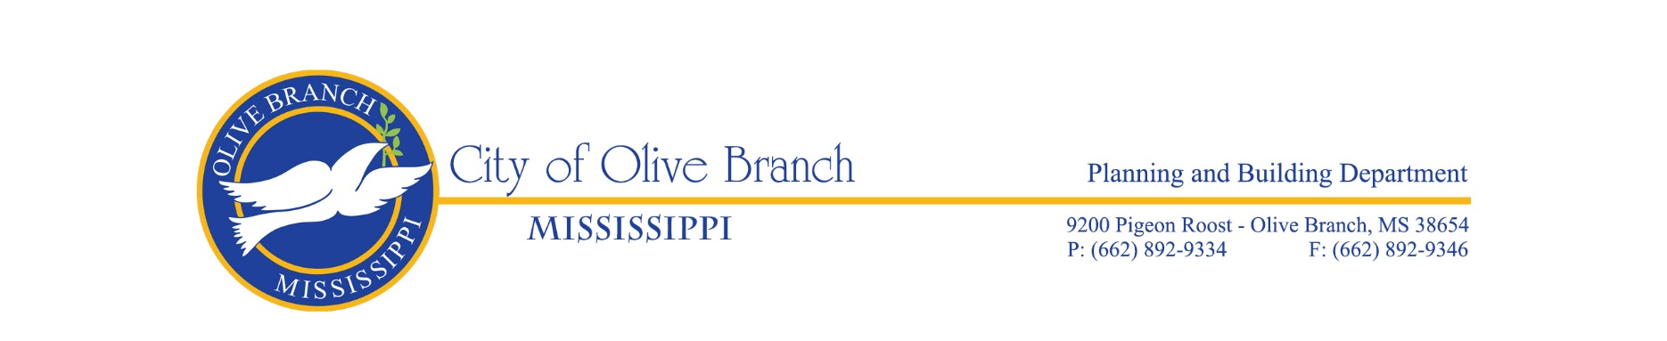

THE CITY OF OLIVE BRANCH DESIGN REVIEW ADVISORY COMMITTEE

AGENDA FOR THE REGULAR MEETING ON JULY 25, 2024

The Olive Branch Design Review Advisory Committee will hold its regular meeting on Thursday, July 25, 2024 in the Planning/Engineering Conference Room, City Hall, Room 143, located at 9200 Pigeon Roost Rd, Olive Branch, MS at 4:00pm.

CALL TO ORDER

ROLL CALL

APPROVAL OF THE MINUTES OF THE REGULAR MEETING OF JUNE 27, 2024

OLD BUSINESS

NEW BUSINESS

- Design Review Application for Contractor’s Supply Plus to install a 800 sq. ft. metal building on the property, submitted by Ricky Thompson, Vice President, Contractor’s Supply Plus, property owner. The 0.69+/- acre subject property is zoned C-2, Highway Commercial District and is located just north of the intersection of Morgan Manor Dr and Hwy 178, known as 9935 Hwy 178. (File #DR24-0006).

- Design Review Application for Canablume, LLC to install a 55,325 sq. ft. metal building on the property to be used for Cannabis Cultivation, submitted by Pastor Darryl Brown on behalf of property owner, Streets of Hope. The 3.19+/- acre subject property is zoned M-2, Heavy Industrial District, and is located on the east side of Highway 178, approx.. 0.20 miles south of New Craft Rd, known as Lot 3 Fortune Industrial Subdivision. (File # DR24-0007).

OTHER BUSINESS

ADJOURNMENT

