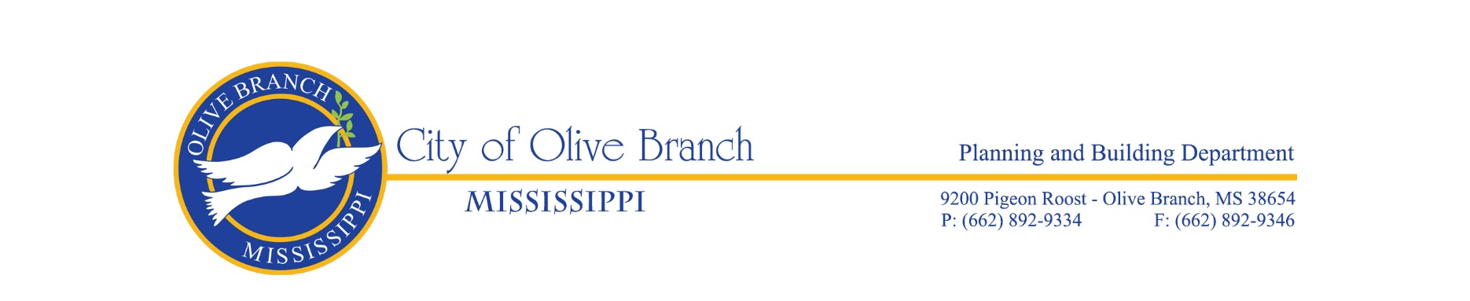

THE CITY OF OLIVE BRANCH DESIGN REVIEW ADVISORY COMMITTEE

AGENDA FOR THE REGULAR MEETING ON JUNE 27, 2024

The Olive Branch Design Review Advisory Committee will hold its regular meeting on Thursday, June 27, 2024 in the Planning/Engineering Conference Room, City Hall, Room 143, located at 9200 Pigeon Roost Rd, Olive Branch, MS at 4:00pm.

CALL TO ORDER

ROLL CALL

APPROVAL OF THE MINUTES OF THE REGULAR MEETING OF JANUARY 25, 2024

OLD BUSINESS

NEW BUSINESS

- Design Review Application for United Quality Plumbing to install a 60,000 sq. ft. metal building on the property, submitted by Taylor Webb, Rockfield Engineering on behalf of property owner United Quality Plumbing, Alex Gomez, President. The 4.37+/- acre subject property is zoned M-2, Heavy Industrial District and is located just east of the intersection of Metro Dr and High Point Rd, Lot 19B of Metro Industrial Park Subdivision. (File #DR24-0004).

- Design Review Application for Temple Baptist Church to install a 600 sq. ft. metal storage building on the property, submitted by Calvin Green, Building and Grounds Committee, on behalf of property owner Temple Baptist Church. The 10.49+/- acre subject property is zoned A-R, Agricultural-Residential District, and is located at the southeast corner of Plantation Rd and Germantown Rd, known as 8432 Germantown Rd. (File # DR24-0005).

OTHER BUSINESS

ADJOURNMENT

